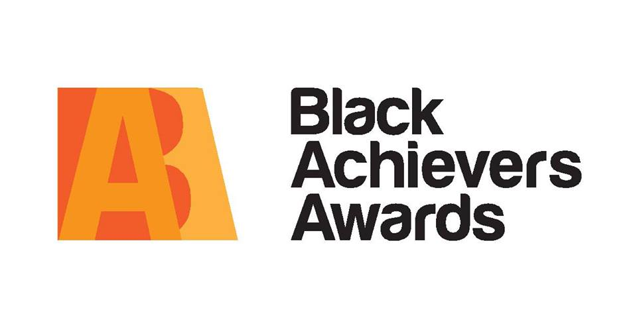

Sports Man & Sports Woman Award
Sponsored by Nottinghamshire YMCA
This category is open to an organization that has helped someone through sport or an individual who has achieved through sport.

Health Award
Sponsored by University of Nottingham
An individual who has experienced a health challenge (mental or physical) and still achieved their goals, or a carer of someone suffering

Young Achiever’s Award
Sponsored by Nottingham Trent University & Tick Tock Crèche
A young male and females aged 18-24 who has overcome professional or personal barriers or excelled in a particular field i.e. business, education or sport.

Outstanding Parent Award
Sponsored by Hope Fostering Service
Nominate a father, a mother or a role model who you value as a parent figure. Express in 200 written words why he/she is the best and include the inspiring things they have done for you and your family.
Community Volunteer Award
Sponsored by Nottingham CVS
Do you recognise the outstanding voluntary contributions made by an individual to the local community? Tell us the about inspiring ways of this person

HOW TO NOMINATE
You can collect and drop off nomination forms from the following outlets-

Nottingham Community and Voluntary Service (NCVS). We can also email you across the nomination form if preferred

You can also place your vote by using our website http://blackachieversaward.co.uk
-------------------------------
Information lines:
General info - Merlita- 07468427469
General info Davia – theblackachieversaward@gmail.com

Nominations postal address:
Nottingham Community and Voluntary Service
7 Mansfield Road (Opposite House of Fraser), Nottingham, NG1 3FB

Awards event details:
Black tie event held on Saturday 22 October, 2016
Venue- East Midlands Conference Centre, University Park, Beeston Ln, Nottingham NG7 2RJ

Times: 6.30pm Doors open for networking
7.30pm event commences

On the night there will be a three course meal, stage entertainments and of course the winners of each award!

Tickets are £21.83 (including booking fee)

Cultural/Music and arts Award
Sponsored by Tuntum Housing & Danielle Beccan Memorial Trust
An individual who has been notably successful in the field of arts and culture. Tell us about the wonderful and creative things he/she has done or is doing

Most Transformed Award
Sponsored by Nottinghamshire Police & Crime Commissioner
A black male or female who you know to have gone through challenging circumstances in life he/she may have been confronted with heavy issues and is now fulfilling his/ her potential and being a role model to others

Business Man & Business Woman Award
Sponsored by Eon
A business man or woman who has overcame the challenges of running a business or social enterprise in Nottingham, someone you feel acts as a positive role model to by going that extra mile to encourage others with business advice and shares his/ her experiences in a positive way

Learning, Skills & Employment Award
Sponsored by Futures Advice & Mojatu Foundation
Recognising and individual who as excelled in providing Learning, Skills & Employment or an individual that has excelled in gaining new skills in Learning, Skills & Employment

Life Time Contributor Award
Sponsored by One Nottingham
An individual with an outstanding record of achievement who has made a significant contribution towards enhancing the lives of people in the Nottingham community.

Closing Date for Nominations: 7 October 2016

PLEASE TURN OVER TO PLACE YOUR NOMINATION
Please note the person you are nominating must be able to attend on the night of the Awards:

Please tick which category you are nominating for? Nominees must be 18+ (Please read the category requirement over leaf and tick the box you wish to nominate in)

 |  | Life Time Contributor Award |  |  | Outstanding Parent Award
 |  | Business Man & Business Woman Award |  |  | Young Achiever’s Award
 |  | Community Volunteer Award |  |  | Health Award
 |  | Cultural, Music & Arts Award |  |  | Sports Man & Sports Woman Award
 |  | Most Transformed Award |  |  | Learning, Skills and Employment Award
Please add the details of the person you are nominating, be as descriptive as possible when explaining why you are nominating this person. Give examples of what they have done to deserve an award.
Nominees Name
Nominees Contact Number
Nominees Email
Your Name
Your Contact Number
Your Email
Why are you nominating this person?

Please attach extra paper if required.

